Discovery Progress Report

***Instructions****: Read all information. Answer all questions. Digitally submit this document with your answers inserted. Name the document your-last-name. Any other documents requested should be uploaded as well, with a similar naming convention, eg your-last-name_1. Realize that your design responsibilities do not end with the questions you answer. The questions are simply there to guide you to pertinent information, relevant steps you might need to take, etc. Each member of the team should submit documentation for Progress Report 1 (even if there are TWO of a given discipline on the team).*

***Design process steps included in this progress report:*** *This progress report primarily addresses the step of “discovery.” Students should be reading relevant documentation, researching applicable technical topics, observing relevant related designs, etc.*

***Teaming Expectations****: While completed individually, the Discovery progress report will form the knowledge basis of the multidisciplinary team. Therefore, team members should inform each other as points of potential integration are discovered, areas of potential difficulty, etc.*

***Documentation Considerations****: The final report will have a chapter devoted to the “discovery” phase of the design project so keeping relevant, organized notes is imperative. Consider using Google Drive or Microsoft Sharepoint to setup a team document archive. Consider setting interim writing deadlines in your project schedule.*

## Design Theory

Prior to solving any sort of design problem, you must learn about the relevant technical issues, find out how similar problems may have been solved and understand the requirements. You must *discover* relevant issues using a variety of resources and references. Old class texts, websites (commercial, professional and hobbiest may be of use), interviews with instructional and Makerspace staff could be useful. Depending on the type of project, you may need to do significant *empathy* work, talking to clients, users and even your teammates. The goal for the end of the discovery phase is to thoroughly understand the underlying physical and technical concepts, as well as the human requirements, so that you can begin to work through what *design tradeoffs* might be. Discovery work often continues throughout the entire project.

Design of the vehicle will involve basic knowledge of dynamics, strength of materials and possibly even some basic circuit design. Of course, scale model off-road vehicles have been designed by many enthusiasts, as a quick internet search will show you, but yours will need to be *engineered.* You will need to understand how Cat’s Conundrum course elements are ranked and scored. You will need to work with your team to determine which elements you want your vehicle to be able to traverse. Ultimately, you will need to understand how the terrain that you wish to traverse translates to engineering *demands* on the vehicle you are designing, which hopefully will have the *capacity* to succeed.

Background Research

Provide evidence of background research exploring methods/products that might meet the functional requirements and objectives. This could be DIY videos, books, blogs, websites, etc. demonstrating the use of the methods/products you identified in a manner similar to how you might use it in your design. The goal is to familiarize yourself with a variety of possible methods for achieving your goal without yet committing to using any particular solution. Objectively identify pros and cons. Stay open to possibilities.

1. Draw a block diagram showing the high-level connections for a circuit that includes a microcontroller, motor driver, servo, battery(s), and receiver for wireless signal. Be sure to specify (explain in words or make clear in your drawing) how each component in the system is powered.
2. EE’s are not allowed to use a commercial ESC (electronic speed control) in their design rather they must use a motor driver board. While the difference between the two is nominal, an ESC come preassembled with wires and possibly pre-programing to be plug and play in RC cars. To illustrate the difference, google search for ESC and switch to the images tab. Repeat the image search, this time for motor driver board. Rule of thumb—if it has wires preinstalled, it is off limits. Provide a screen clip of any ESC and any motor driver.
3. What is a BEC? (Note that you cannot use a commercial purchased BEC in your design).
4. There are many microcontrollers on the market today. While they often provide a variety of feature and varying specs, their primary functionality is similar. To familiarize yourself with a common design, explain the role of each of the numbered components on an Arduino Uno picture below.
   1. What programming language does this board utilize? If applicable, does your Comp Sci know this language?

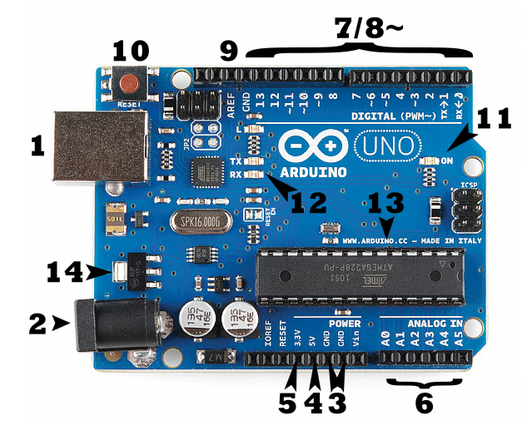

1. What is the maximum current output from an Arduino Uno GPIO pin? What would happen if you hooked up a motor to this pin that has a no-load current draw of 0.10 A and a stall current of 1.5 A?
2. Draw a simple circuit you could use to drive a motor using a single transistor. What is the primary limitation of using a single transistor? What is an H-bridge? How could it be used to drive a motor? (While you are not required to build your own motor driver circuit, this question forces you to explore how they work. Note that high performing teams in the past have built their own motor driver boards; it is possible).

Mathematical Model

Construct a mathematical model that allows the calculation of needed design metrics. Where possible, please use a Given, Find, Assumptions, Diagram, Solution format to present your work. This model should be in spreadsheet form and use estimated initial values. Provide a rational for any estimated values in your assumptions section. This model will guide future purchases.

1. **Complete the following problems:**

**GIven:** Your ME has suggested he/she needs a motor with at least 125 RPM and 35 oz-in of torque and a servo with 20 oz-in of torque

**Find:**

1. Use <https://www.pololu.com/> to find a suitable 6 V, micro-metal gear motor and 6 V servo.
   1. Provide a screen clip showing the physical dimensions of the motor and servo. Are these generally in the right ball park in terms of size for your design?
   2. What is the no load current and the stall current for the motor and the servo?
   3. Output power at max efficiency of the motor?
   4. Cost?
2. **Given:** Given the max current draws from the servo and motor above.

**Assume:** The current draw from the microcontroller and other components in your system are negligible compared to the motor and servo.

**Find: Use Excel** to create a spreadsheet **that you submit with this document** which answers the following questions based on easy to update input parameters.

* How long will a 350 mAH 35C 2S LiPo last if you drove your car and servo at full current draw continuously?
* Find both a LiPo a with the above specs and a NiMH equivalent. Compare size and price. Explore various websites for best deal and ship time.
* Is the assumption that the other components in your system have negligible current draws a reasonable assumption? If not, you will need to add the other components to your Excel model. Explain your thinking.
* Continue to add features to your Excel document throughout the semester creating a tool that you can use to quickly find need design specs as your project evolves. Are there other specs/parameters that you will need to quickly calculate?

**Hint:** <http://multicopter.forestblue.nl/lipo_need_calculator.html>   
**Cheap Parts but slow shipping and poor specs:** <https://hobbyking.com/en_us> (some parts ship from China. Parts in US warehouse ship faster).

**Expensive but good spec sheets (moderate ship times):** <https://www.pololu.com/>

**Excellent Tutorials and ok spec sheets (moderate ship times):** <https://www.adafruit.com/> and <https://www.sparkfun.com/>

Note that these products can often be found on Amazon Prime for fast shipping at a high price.

1. **Given**: Your ME changes his/her mind and now wants a motor with at least 250 rpms and 90 oz in with the same servo.  
   **Find:** Use your Excel tool to find your new battery needs and determine if the battery size will be physically too large to fit in your design? How much weight do this battery add to your design? Does it change the size/form factor of the motor?

## Other questions

In class, you brainstormed a list of questions with your teammates. If you answered any those questions, articulate that here. If you know of any other outstanding questions that you still need to answer, that may also be articulated here.

Resources Identified

All physical resources available at Makerspace and Light Build Room (NAH 220) have been identified and examples of how to use these resources documented and studied. Commercial resources have been investigated for purchase of physical components. Complete the Motor Specification Sheet (attached at the end of this document)

|  |  |
| --- | --- |
| **Identify at least one resource locally where you could procure parts for your vehicle.** |  |
| **Identify at least two sources online where you could parts for your circuit (beyond the sites mentioned in this document). Identify shipping time and cost.** |  |
| **List of resources in Makerspace and Light Build room that will be of use as you build your design.** |  |

## References

**Include those that you used to complete this assignment (including those given in the document). Use standard formatting so that these references can be copied into your final report.**